Topic 13: Future Enhancements Documentation (Enterprise Roadmap & Long-Term Vision)
This document outlines the **strategic future enhancements** planned for the system.
These enhancements are designed to elevate the application into a fully scalable, AI-powered, enterprise-level platform capable of supporting millions of users.
The roadmap follows long-term software engineering principles used by global companies such as Google, Amazon, Meta, Microsoft, and Netflix.
Each enhancement aims at improving:
• Performance
• Scalability
• User experience
• Security
• Automation
• Business value
---
# 1. High-Level Future Enhancement Roadmap
Below is a visual roadmap diagram showing the key enhancements planned:
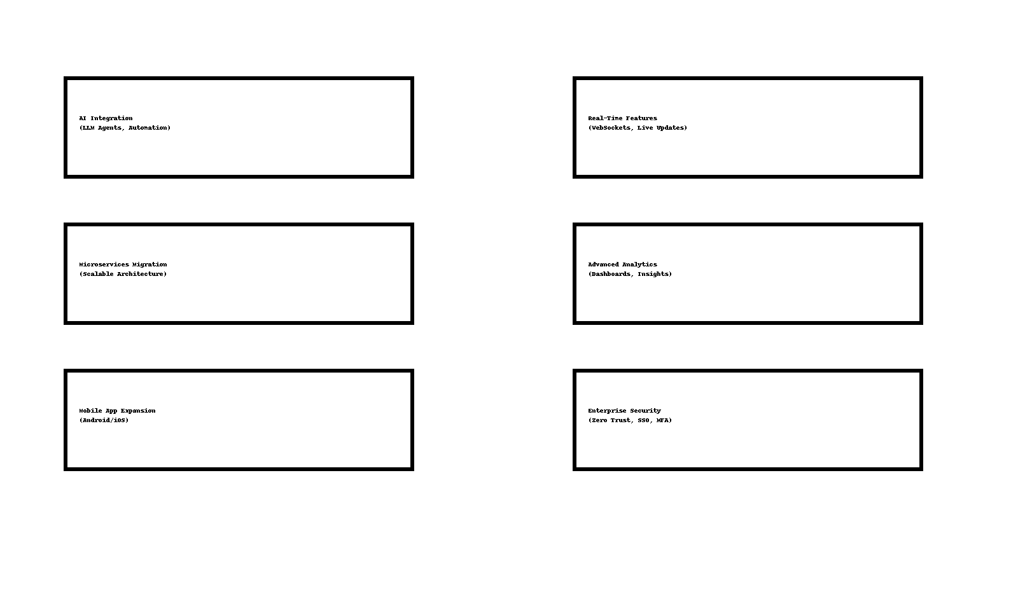
---
# 2. Enhancement 1: AI Integration (Next-Gen Intelligence)
### Description
AI will be integrated to provide smart recommendations, automated workflows, and conversational capabilities.
### Features Planned
• AI chat support inside platform
• Intelligent book search & recommendation engine
• Automated admin tasks
• Predictive analytics
### Technology Stack
• LLMs (GPT, LLaMA, Gemini)
• Vector databases
• Real-time inference engines
---
# 3. Enhancement 2: Migration to Microservices Architecture
### Description
To support massive scaling, the backend can be split into microservices.
### Benefits
• Independent deployment
• Faster development cycles
• Horizontal scalability
• Improved fault isolation
### Candidate Microservices
• Auth service
• Book service
• Notification service
• Analytics service
---
# 4. Enhancement 3: Mobile Application Expansion (React Native / Flutter)
### Description
Create a cross-platform mobile application for Android and iOS.
### Features
• Offline mode
• Push notifications
• Secure mobile authentication
• Mobile-friendly dashboards
This enables wider user accessibility.
---
# 5. Enhancement 4: Real-Time System Capabilities
### Description
Enable real-time communication across the platform using WebSockets.
### Use Cases
• Live updates for admin actions
• Realtime notifications
• Collaborative features
• Activity streams
### Tools
• Socket.io
• WebRTC
• MQTT
---
# 6. Enhancement 5: Advanced Analytics & Reporting Dashboard
### Description
A professional analytics engine will allow tracking user activity, book performance, and system metrics.
### Planned Features
• Heatmaps
• User retention analytics
• Trend forecasting
• Exportable reports (PDF, Excel)
This helps businesses make informed decisions.
---
# 7. Enhancement 6: Enterprise Security Upgrades
### Description
Upgrade platform to meet enterprise-grade compliance standards.
### Features
• Single Sign-On (SSO)
• Multi-Factor Authentication (MFA)
• Zero Trust Security Model
• IP whitelisting
• Audit logs
These ensure maximum protection against cyber threats.
---
# 8. Enhancement 7: Cloud Infrastructure Optimization
### Description
Deploy systems on scalable cloud platforms with modern DevOps.
### Enhancements
• Kubernetes orchestration
• Auto-scaling
• Serverless functions
• CDN optimization
• Multi-region deployment
This ensures global availability and reliability.
---
# 9. Enhancement 8: Full Accessibility Compliance (WCAG 2.1 AA)
### Improvements
• Keyboard navigation
• High contrast modes
• Screen-reader support
• Voice assistance integration
This makes the system inclusive and professional.
---
# 10. Enhancement 9: API Versioning & Public Developer Platform
### Description
Expose APIs to third-party developers.
### Planned Additions
• API v1, v2 migration
• Public docs & API keys
• Rate limiting & usage analytics
This enables the system to become a platform ecosystem.
---
# 11. Enhancement 10: Automated Testing Expansion
### Description
Add full automation coverage.
### Enhancements
• 90%+ test coverage
• Stress testing
• Automated regression tests
• Chaos testing (Netflix-style)
This ensures unmatched system stability.
---
# 12. Conclusion
This Future Enhancements Roadmap defines how the system will evolve into a highly scalable, AI-driven, enterprise-level platform.
These planned upgrades ensure the product remains future-proof, competitive, and ready for global deployment.
This concludes **Topic 13: Future Enhancements Documentation**.

